THE LOVE BOAT – Paul Williams and Charles Fox
Television Theme Song

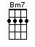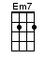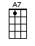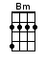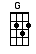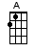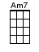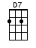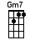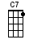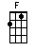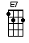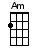

[D] Love, ex-[Bm7]citing and new,
Come a-[Em7]board, we're ex-[A7]pecting you,
And [D] love, life's [Bm] sweetest reward,
Let it [G] float, it floats [Em7] back to you [A]

The [Am7] love boat [D7]
Soon will be [G] making another run,
The [Gm7] love boat [C7]
Promises [F] something for every-[E7]one,
Set a [Am] course for adventure,
Your [Am7] mind on a new ro-[G]mance [A]

And [D] love, won't [Bm7] hurt anymore,
It's an [Em7] open smile, on a [A7] friendly shore,
It's [D] love…
[G] Welcome a-[A]board it's [D] love…
[G] Welcome a-[A]board it's [D] lo-[G]-o-[D]-ove [D]↓

www.bytownukulele.ca

