ON A SLOW BOAT TO CHINA by Frank Loesser (as sung by Jimmy Buffett)

Opening notes: {A3} {A3}{A4} {A4}{A5}{E2}{E3}{E3}{A2} (repeat)

Verse 1:
[C] I’d love to [A7] get you
On a [F] slow boat to [F#dim] China
[C] All to my-[E7]self
A-[F]lone [A7]
[F] Get you and [F#dim] keep you in my
[C] Arms for ever-[A7]more
[D7] Leave all your lovers
[Dm7] Weeping on the faraway [G7] shore

Verse 2:
[C] Out on the [A7] briny
With the [F] moon big and [F#dim] shiny
[C] Melting your [E7] heart
Of [F] stone [A7]
Honey [F] I’d love to [Fmin] get you
On a [C] slow boat to [A7] China,
[D7] All by my-[G7]self a-[C]↓lone -{A3}{A4} {A4}{A5}{E2}{E3}{E3}{A2}

{A3}-{A3}{A4} {A4}{A5}{E2}{E3}{E3}{A2}

Strum chords for verse 1 (kazoos)

Verse 3:
[C] I’d love to [A7] get you
On a [F] slow boat to [F#dim] China
[C] All to my-[E7]self
A-[F]lone [A7]
[F] A twist in the [F#dim] rudder
And a [C] rip in the [A7] sails
[D7] Drifting and dreaming
Honey [Dm7] throw the compass over the [G7] rail

Verse 4:
[C] Out on the [A7] ocean
Far from [F] all the [F#dim] commotion
[C] Melting your [E7] heart
Of [F] stone [A7]
Honey [F] I’d love to [Fmin] get you
On a [C] slow boat to [A7] China
[D7] All by my-[G7]self a-[C]↓lone
-{A3}{A4} {A4}{A5}{E2}{E3}{E3}{A2} [C]↓

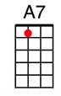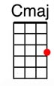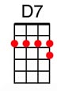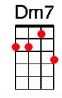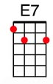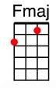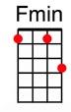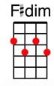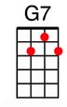

www.bytownukulele.ca

