Opening notes: Bb, Bb, B, B, C, E, F, F, A (repeat)

Verse1:

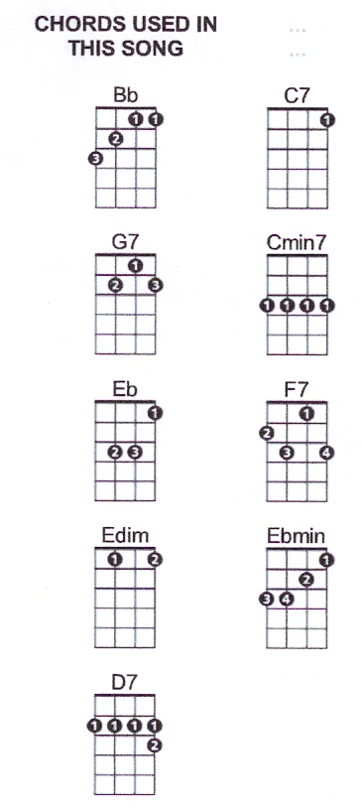[Bb] I’d love to [G7] get you
On a [Eb] slow boat to [Edim] China
[Bb] All to my-[D7]self
A-[Eb]lone [G7]
[Eb] Get you and [Edim] keep you in my
[Bb] Arms for ever-[G7]more
[C7] Leave all your lovers
[Cm7] Weeping on the faraway [F7] shore

Verse 2:

[Bb] Out on the [G7] briny
With the [Eb] moon big and [Edim] shiny
[Bb] Melting your [D7] heart
Of [Eb] stone [G7]
Honey [Eb] I’d love to [Ebmin] get you
On a [Bb] slow boat to [G7] China,
[C7] All by my-[F7]self a-[Bb - 1 downstrum]lone

….., Bb, B, B, C, E, F, F, A
Bb, Bb, B, B, C, E, F, F, A

Strum chords for verse 1 & kazoo

Verse 3:

[Bb] I’d love to [G7] get you
On a [Eb] slow boat to [Edim] China
[Bb] All to my-[D7]self
A-[Eb]lone [G7]
[Eb] A twist in the [Edim] rudder
And a [Bb] rip in the [G7] sails
[C7] Drifting and dreaming
Honey [Cm7] throw the compass over the [F7] rail

Verse 4:

[Bb] Out on the [G7] ocean
Far from [Eb] all the [Edim] commotion
[Bb] Melting your [D7] heart
Of [Eb] stone [G7]
Honey [Eb] I’d love to [Ebmin] get you
On a [Bb] slow boat to [G7] China
[C7] All to my-[F7]self a-[Bb - 1 downstrum]lone
….., Bb, B, B, C, E, F, F, A, [Bb - 1 downstrum]

