It Takes A Lot To Laugh, It Takes A Train To Cry

Bob Dylan

The song is mostly a blues shuffle between C and AM so when you see the [C/Am] it is holding down the First-string-third-fret and dropping and releasing the fourth-string-second-fret.

INTRO: HARMONICA AND UKES – FIRST VERSE
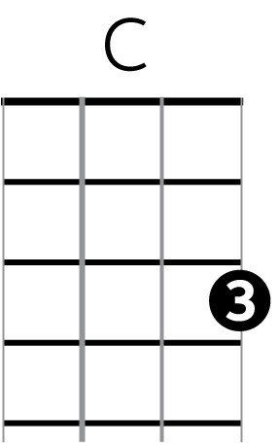
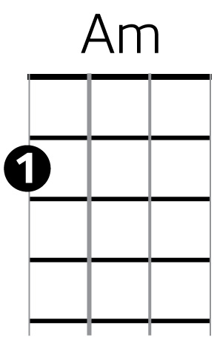
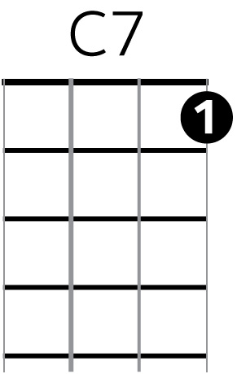
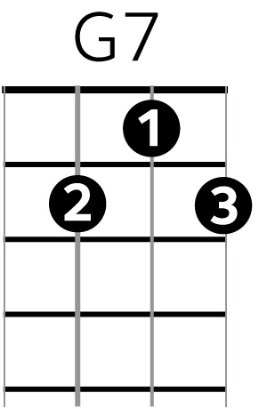
[C/Am] Well, I ride on a mail train, baby
Can’t buy a thrill
Well, I’ve been up all night, baby
Leanin’ on the window sill
Well, if I [C7] die
On [F] top of the [G7] hill [STOP]
And if [C/Am] I don’t make it
You know my baby will

[C/Am] Don’t the moon look good, mama
Shinin’ through the trees?
Don’t the brakeman look good, mama
Flagging down the “Double E?”
Don’t the sun look [C7] good
Goin’ [F] down over the [G7] sea? [STOP]
Don’t my [C/Am] gal look fine
When she’s comin’ after me?

[C/Am] Now the wintertime is coming
The windows are filled with frost
I went to tell everybody
But I could not get across
Well, I wanna be your [C7] lover, baby
I don’t [F] wanna be your [G7] boss [STOP]
Don’t [C/Am] say I never warned you
When your train gets lost

