Bob Dylan - When the Deal Goes Down (C) - 3/3 - harp C(maybe F)

C E7 F Dm7
In the still of the night, in the world's ancient light
C G7 C G
Where wisdom grows up in strife
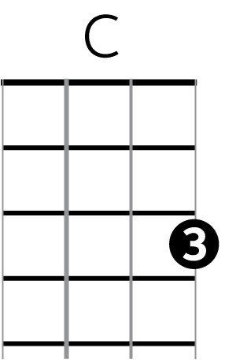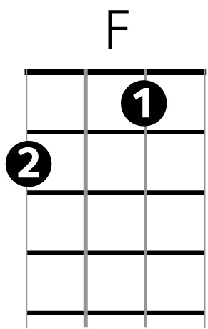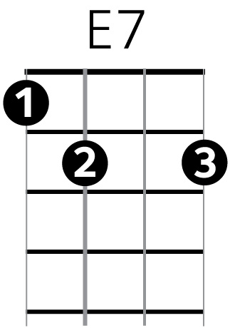
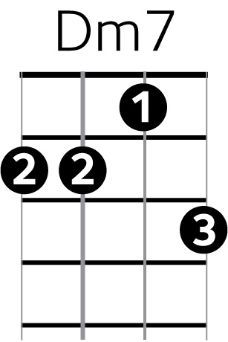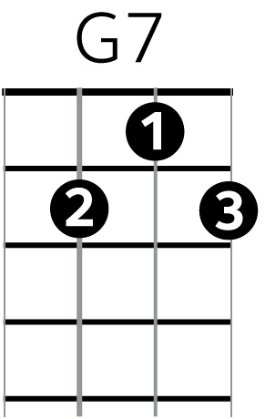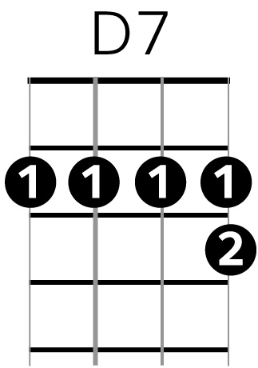
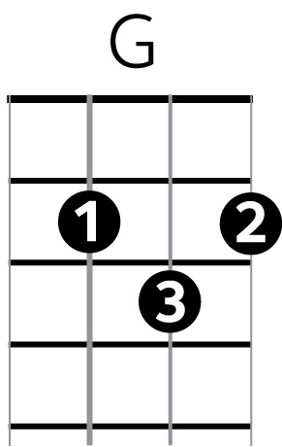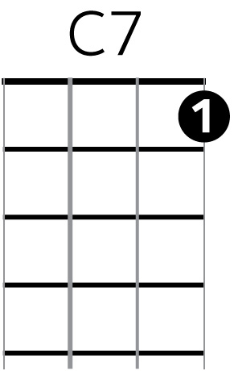
C E7 F Dm7
My bewildered brain, toils in vain
C G7 C C7
Through the darkness on the pathways of life

F Dm7 C
Each invisible prayer is like a cloud in the air
F C D7 G7
Tomorrow keeps turning around
C E7 F Dm7
We live and we die, we know not why
C G7 C
But I'll be with you when the deal goes down

We eat and we drink, we feel and we think C E7 F Dm7
Far down the street we stray C G7 C G
I laugh and I cry and I'm haunted by C E7 F Dm7
Things I never meant nor wished to say C G7 C C7

The midnight rain follows the train F Dm7 C
We all wear the same thorny crown F C D7 G7
Soul to soul, our shadows roll C E7 F Dm7
And I'll be with you when the deal goes down C G7 C

[guitar solo - 2 lines(or more)]

The moon gives light and it shines by night C E7 F Dm7
Well, I scarcely feel the glow C G7 C G
We learn to live and then we forgive C E7 F Dm7
O'er the road we're bound to go C G7 C C7

More frailer than the flowers, these precious hours F Dm7 C
That keep us so tightly bound F C D7 G7
You come to my eyes like a vision from the skies C E7 F Dm7
And I'll be with you when the deal goes down C G7 C

Well, I picked up a rose and it poked through my clothes C E7 F Dm7
I followed the winding stream C G7 C G
I heard the deafening noise, I felt transient joys C E7 F Dm7
I know they're not what they seem C G7 C C7

In this earthly domain, full of disappointment and pain F Dm7 C
You'll never see me frown F C D7 G7
I owe my heart to you, and that's sayin' it true C E7 F Dm7
And I'll be with you when the deal goes down C G7 C

